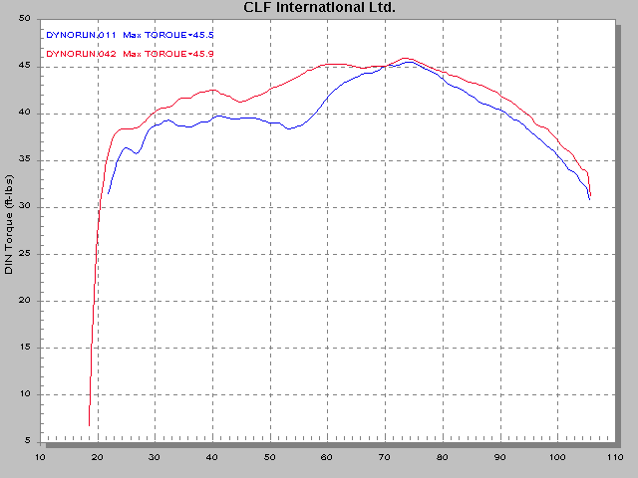
Redline = Bike fitted with Micron full system.

Blueline = Std Bike.

