Removing & Replacing sized pins in the rear calliper.

One of the little faults of the SV, is that the rear pins of the brake calliper size in their mountings. The pins go into a blind hole, so you cannot tap them out as mentioned in the Haynes manual…ammeters. What I have done is replace the pins with longer, headed versions, and drilled the back of the calliper. This will enable you to remove them a lot easier next time.
Remember, brake fluid is corrosive to paint work. Protect surfaces with rag etc.

Things needed:

Ratchet with 14mm socket | Reasonable weight hammer
14mm Spanner | 3.5 & 4.5mm drill bits (Sharp)
Long Nose pliers | Scribe (or map pin)
Pin Punch | New brake pins
Copper ease | Brake cleaner
Round Needle file | Toothbrush!
Kitchen towel | Rag/cloth etc.
Can of lager

Right got all that? Cool let’s start.

To remove the calliper from the bike:
- Remove the brake hose banjo bolt from calliper and hose and replace back into calliper to stop dirt ingress. Place a rag underneath to catch fluid, also rap a piece of kitchen towel round the end of the hose again to stop dirt getting in.
- Remove the bolt from the torque arm and pull the torque arm down.
- Remove the 2 bolts from the calliper mounting.
- Remove Calliper
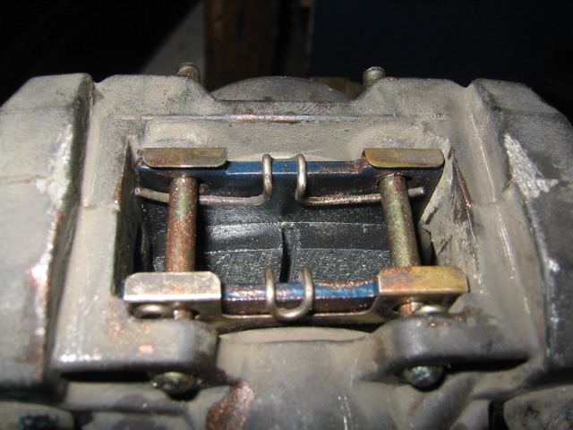
- Remove the plastic cover from the bottom of the calliper, and place to one side. This will expose the pads, pins and the R-clips. You can at this point give the calliper a quick wipe over to remove excess dirt etc.

- Remove the R-Clips and anti rattle springs and place to one side.
- With the scribe, a map pin or similar will do, approximately work out and mark the centre of the brake pins on the back of the calliper. Remember measure twice (or more) drill once!!
- When happy, drill a pilot hole using the 3.5mm to a depth of about ¾ to 1 cm deep. Note: Drill a little bit, then check, if not happy, drill a little more until happy with depth.
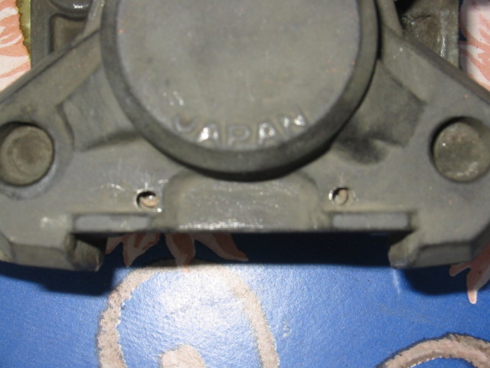
- Take your pin punch, place in hole, and hammer pin out. Repeat on other pin. I found mine to take a damn good beating to remove them from the calliper.
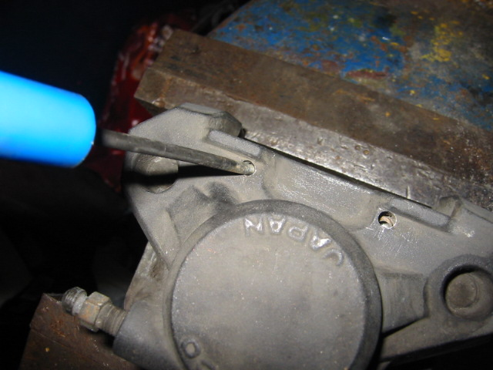
- Remove pads. Give the calliper a good clean. This is where you the toothbrush comes in. Squirt brake cleaner all over. Try to scrape the caked on brake dust off.
- Check that the pins will fit the front (Original) hole, they are long enough to go all the way through the calliper, and also make sure that the r-clip hole is the same distance from the head of the pin as the old ones
- Drill out the rear holes using the 4.5mm drill bit.

- Put pin in, and file hole so that the pin will Is snug but not tight in the new hole. Check: When pin is fully pushed in, make sure that the r-clip hole is accessible as well.

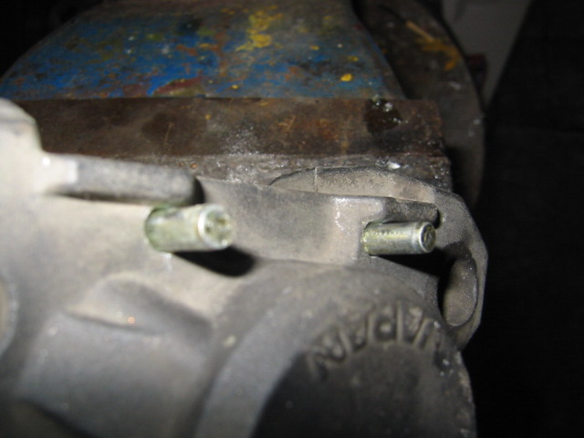
- When happy with the pins, put new pads in calliper remembering to copper ease the back of the pad, and putting the shim on the back…. oh! these are probably still on the back of the old pads. Remove them give ‘em a clean.
- Slide pads in the calliper also fitting the anti rattle springs.
- Copper ease the new pins and slide in.
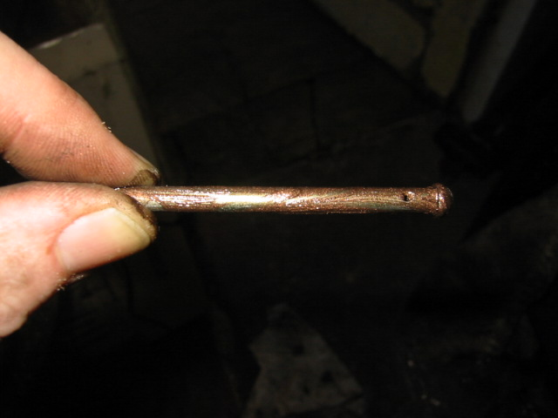

- Replace the R-Clips
- It should look something like this
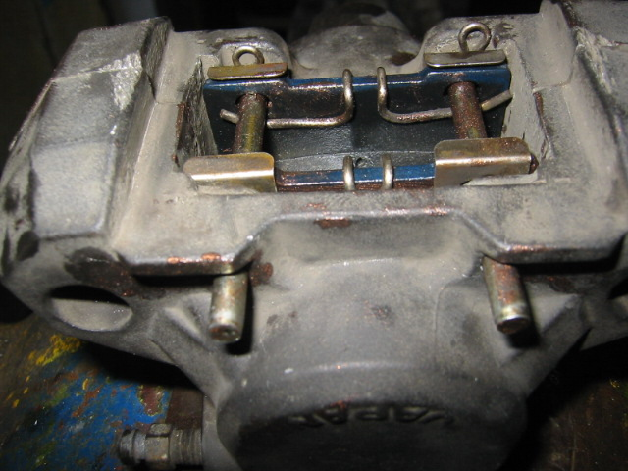
- Give another clean with Brake cleaner
- Refit the plastic cover
- Refit calliper to bike. This is the reverse of the removal

Torque settings

Calliper mounting bolts 39nm
Banjo Hose bolt 23nm
Torque arm bolt 39nm

- Bleed brake system. Note: there are 2 bleed nipples.

There job done. Time for that beer.

