Fill the Grab-rail Gap

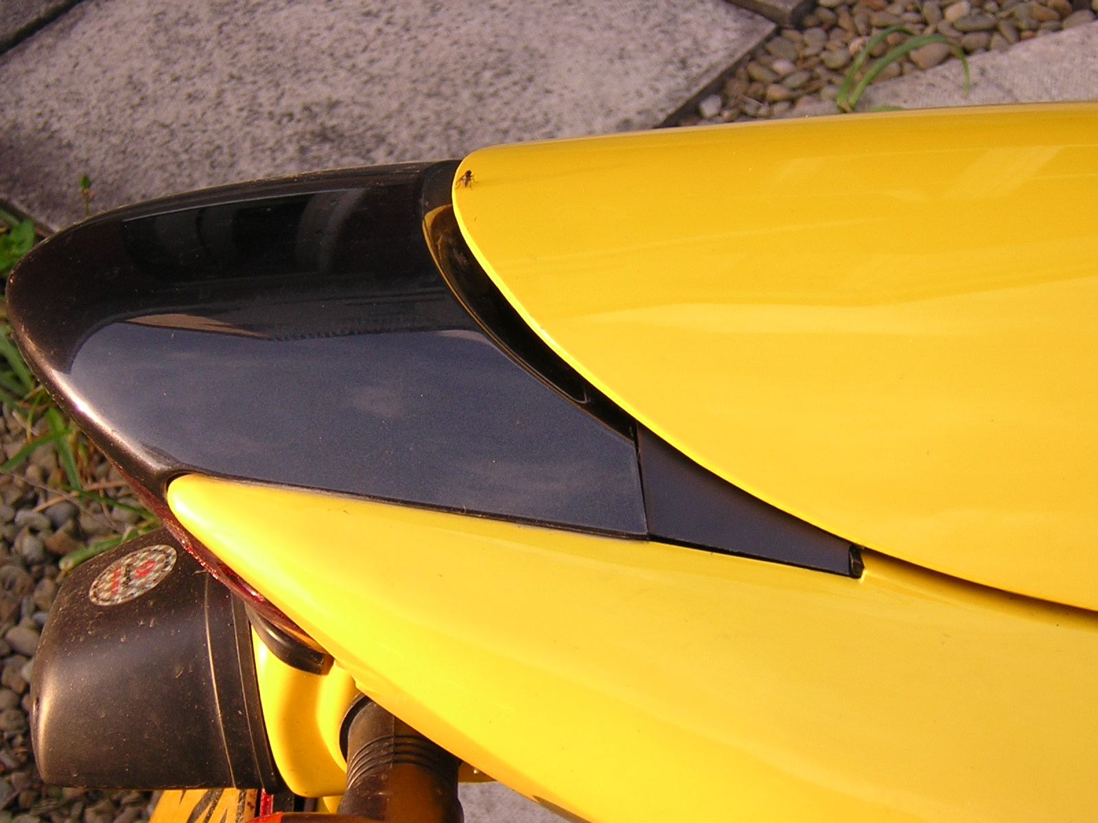
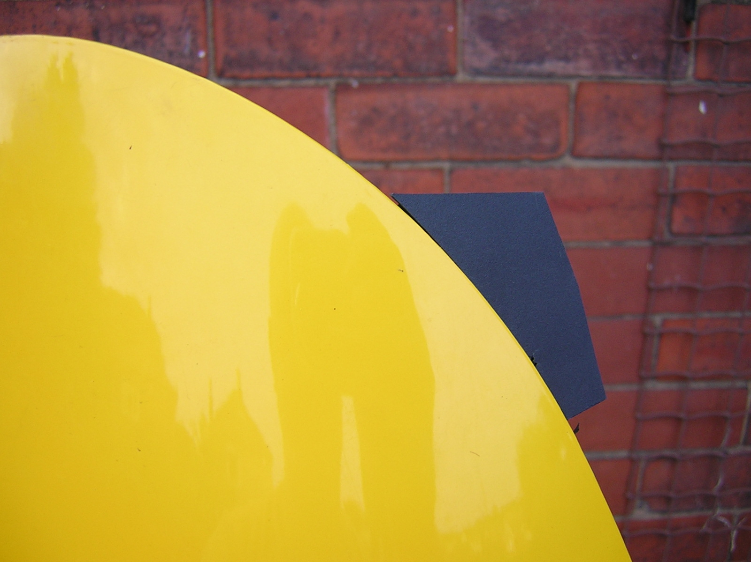

With the OEM seat cowl on and the grab rail removed, the gaps left are a bit unsightly. So to fill the gaps you’ll need 2 floppy disks, scissors and insulating tape.

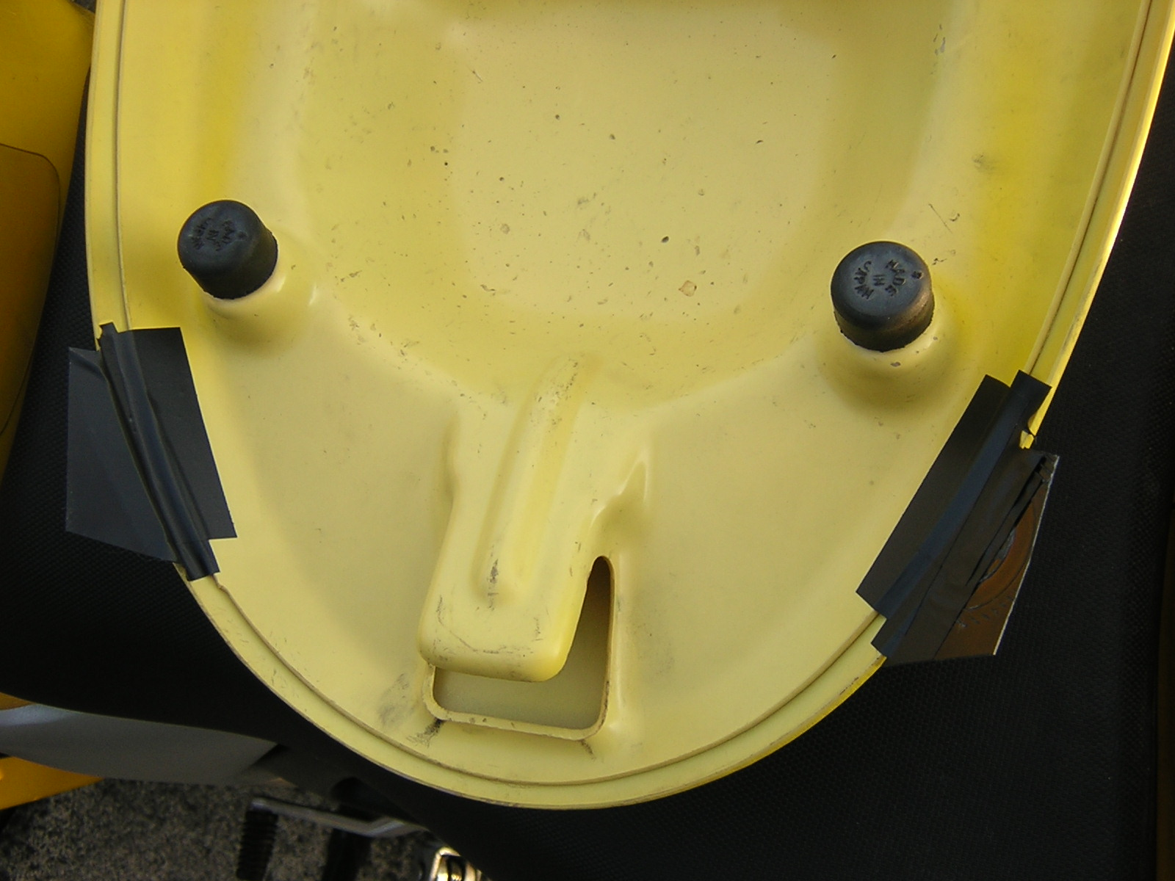
Split the disks and cut out the flat front square bit where the label usually sits. Mark with tape on the seat cowl where the hole is. Hold one edge of the disk plastic against the inner lip of the seat cowl and mark out the curve of the seat cowl. Tape the plastic from the underside

Replace the seat cowl and cut the plastic to fit.

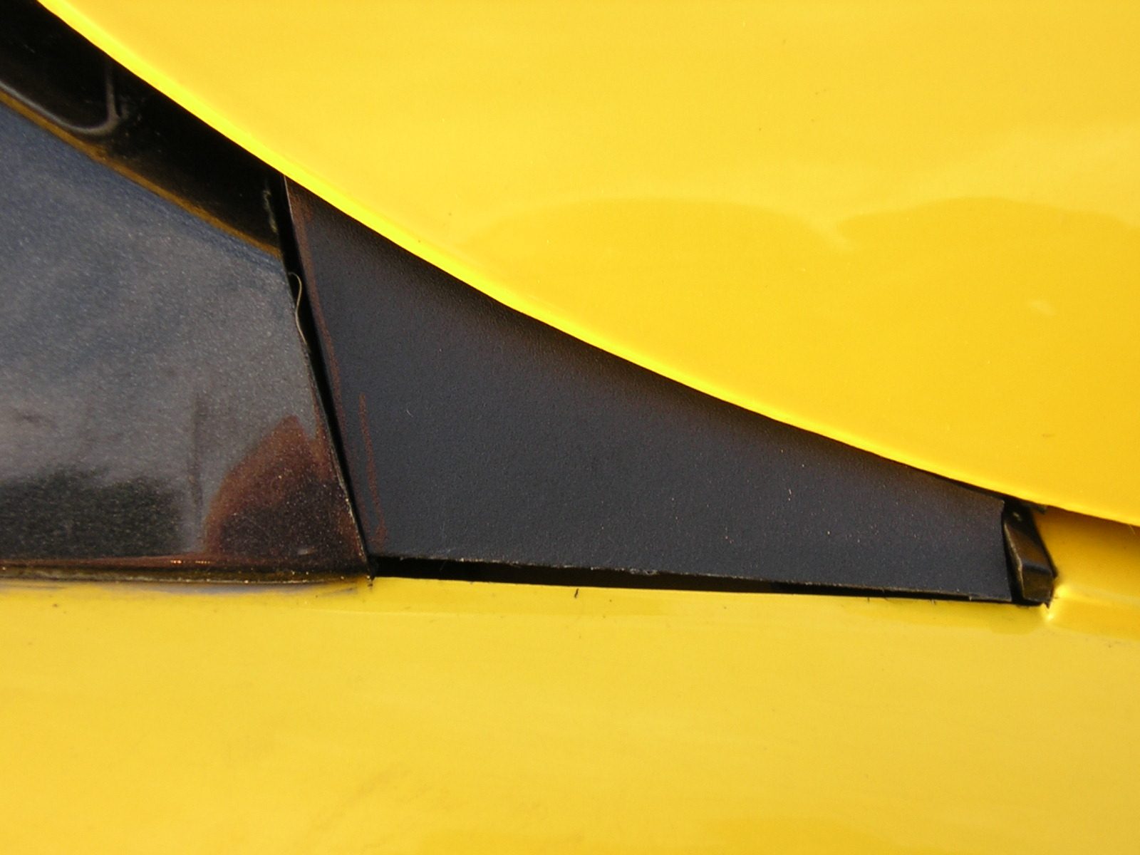
The colour match is good and the disks are cheap and widely available. The job should take less than 30 minutes. It doesn’t look bad from a distance and this photo was taken close up with the macro setting. If anyone can improve on this then please let me know.

