A year ago my MOT tester brought to my attention a slight radial movement on one front disc. I since found out that while floating discs are meant to move slightly from side to side, any forwards and backwards movement, in the direction of rotation, is frowned upon. The bike passed the MOT, however I was advised that by the next test the disc might be too loose and it could become dangerous. I hadn’t detected anything even under heavy braking and as the tester also happens to specialise in discs, I kept a watching brief but left things alone.

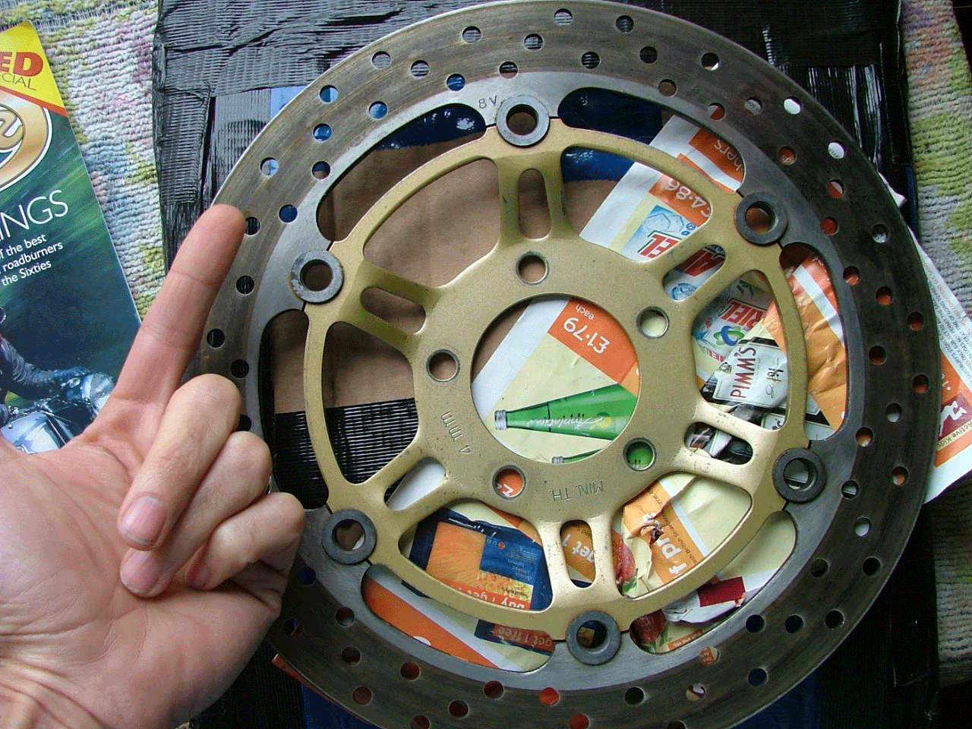
Finger shows direction of ‘improper’ movement

Eight months later, although the rotor (outer steel part onto which the pads bear) was well over the 4mm minimum thickness, the fitting at the bobbins (aluminium rings inserted between inner and outer disc) was getting sloppy enough for me to investigate things pre-test. I found a website where you can ask MOT questions http://www.motester.co.uk and asked about the disc movement. Jim Punter replied:
‘Whilst I am not an expert on motorcycle MOT Tests, given that a disk brake would be checked in the same way as a car’s disk would be checked, I would have thought that this should have been a failure. So it seems to me that the Tester is being over generous with you… …I would have thought that a loose brake disk is very dangerous and I for one would not drive a vehicle in that condition.’
With the best will in the world, the author cast too many doubts (and misspellings?) about in his reply, so I took it a little further. A mate called Steve who repairs bikes for a living (Siddons Bikes 0114 2816575), pointed out that as the movement was only on one disc I wouldn’t feel it because the good side held things firm - but this didn’t mean it was safe or dangerous. He further suggested that it would more than likely be the softer aluminium centre (spider-like part that bolts onto the wheel hub) that had worn, rather than the harder steel rotor.
This made sense and I presumed I could just get an inner and a set of bobbins to fit to my healthy rotor. However most dealers told me that I should replace the discs complete and in pairs (that’ll be 250 quid plus new pads, ta muchly). The latter part is fair comment, but I still wasn’t convinced I should have to pay out for parts I felt I didn’t need. Suzuki themselves don’t sell disc parts, only complete units. That might be interpreted as corporate laziness or greed, or even a gambit to prevent incompetent people trying to bodge brakes dangerously; but doesn’t help without an explanation. My searches around other brake part suppliers came back with a similar picture – I needed to get a pair of discs and the best deal was with my mate Steve (just under £200 the pair but I’d still need pads too).
A quick neb on eBay changed things radically as I successfully bid on a pair of used discs, costing £99 including postage. But then came the disappointment; both of these had radial movement despite the seller saying that the bobbins were tight. It could have been a genuine mistake as he hadn’t used them (long story). I did some checking so that he and I might decide whether I should return the discs or not and found the MOT Tester’s Manual on line at http://www.motuk.co.uk/welcome.htm which states:
‘Fully floating brake discs are designed to have some movement. Care must be taken to not unnecessarily fail these items for security.’
Whilst this could suggest that even my own discs might be OK, it would therefore also mean I might have spent money I didn’t have too (regardless of the condition of the discs I’d bought).
To make double sure (not least because I was now more suspicious of an MOT tester who sold the things he advised me to fit), I took the discs I’d bought to my mate Steve who shook his head. In the interests of safety he refused to fit them. It looked like they’d have to be returned.
In my parallel search for parts rather than whole discs I also found a motorcycle engineer (who may prefer to remain anonymous) in the Yellow Pages. I asked him about my predicament, just to get an unbiased arbitrary view. The bloke said that it was possible that someone may fix this condition by using an item that doesn’t exist – namely over-size bobbins. This he would advocate on an outfit, but wouldn’t advise that procedure for a solo machine.
So it seemed I was right to think discs could be rebuilt, but wrong because it wasn’t deemed ‘safe’ on a solo. Oo-er, just had a nightmare vision of an SV with a huge (colour-matched) Watsonian.
After taking the dispute further with the bloke who sold me the discs, the emails stopped coming back. I reluctantly took out an action through Paypal to get my money back. He seemed a decent bloke but I’m no mule’s fool. While I awaited that outcome, I had some brakes to fix.
I found an ad in ‘Motorcycle Nudes’ for a firm called Trade Direct (01142750111) who sold ‘Rebuild Kits’. As I went to dial the number I recognised the firm – it was my MOT garage.
They said I could have a coloured bobbin kit if I liked and if bobbins didn’t fix the problem they would refund the fee providing I bought discs from them. Sadly though, even they couldn’t provide new inners – surely some entrepreneur will see this hole in the market?
I booked the SV in with Steve to see what we could do (I used to do all my own repairs but age and health now allow me to savour the fruits of other people’s graft). Once the discs were dismantled, we were dismayed at the amount of play – a good few mm on the wayward one, now joined by some movement on the better side. We resigned ourselves to new discs (again) but Trade Direct didn’t have any in. Steve left me trying to polish my rims and took the units over Trade Direct as they said they might have some un-sold specials that might fit (no extra cost).
Whilst there, Steve learnt that some motorcycle racers prefer to have some slack in their discs as this helps to cool them. It is confirmed science that heat is one of the main factors in diminished brake performance. And if people who regularly exceed 200mph are happy with flapping discs, then neither I nor any MOT tester has much room for complaint (unless said item looked, in the vernacular, shagged).
On his return, Steve also had a wry smirk as he held out a hand full of the non-existent oversize bobbins I’d heard of earlier.
When bobbin kits are fitted, wavy washers are normally only placed on the same inner side as the circlips. Steve rebuilt my discs with the additional security of wavy washers on both sides. This has taken the slack up to an almost negligible shift. If I hold the front brake on and try to move the bike back and forth there is a slight movement – one you might mistake for head bearings. But it’s not distressing. The bike now stops fine – (always did) although there seemed to be a bedding-in period of a few miles.

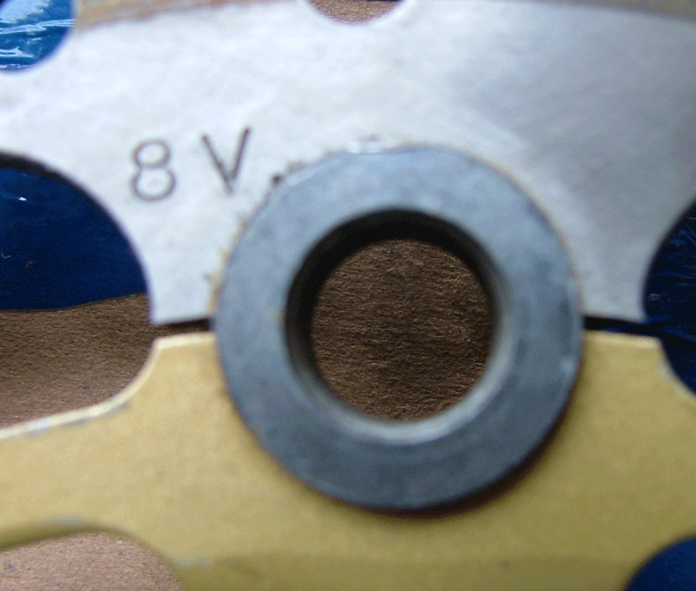
Normally no washer on outer face

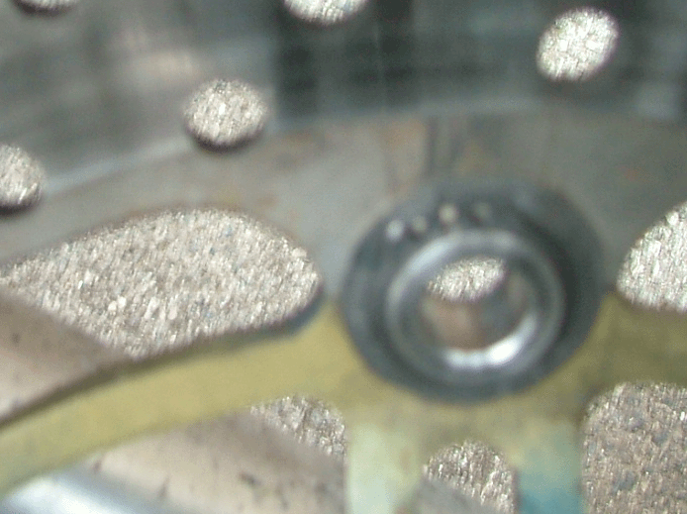
Usual washer fitting on inner face

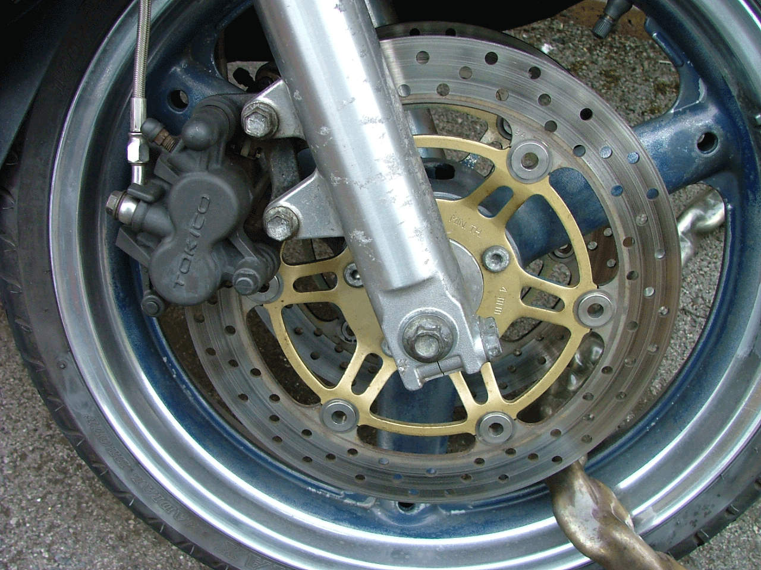
Over-view with new bobbins, extra washers (& slight polish to rim)

The test isn’t while September so we must await what happens then. I’ll also try to fill in later what happens with the eBay dispute. But meanwhile, I think this story throws up as many questions as it answers.
Certainly SVs of a similar age (despite lower mileage, which the bike from which my second-hand discs came was said to have done) are going to suffer the ‘commonality syndrome’ among their complaints. So users/buyers of second-hand parts should be thorough, especially as it is obvious that Suzuki have deployed cost-saving tactics throughout the construction and manufacture of ‘99 SVs at least.
Furthermore, the on-line tester’s manual did not bother to suggest any wear limits or tolerances for radial disc movement. So if your bike fails on this and you are convinced that the discs are OK – dispute it. Save money and hassle but always go back to the adage to end all adages –‘ if in doubt, leave it out.’ Your life is the most important factor in any equation.

Ride Free
Alex

